Switches are the networking devices that work on layer 2 ie: Data Link Layer of OSI reference model. They connect devices in a network and use the method of packet switching to send, receive or forward packet over the network. Switches has many ports. When data frame arrives at the port of switch it checks the destination address, perform the necessary checks and forward the packet in the destination devices. It uses the MAC(media access control) to send data packet to the selective address. Switches support unicast, multicast and broadcast.

Unicast: single sender and single receiver(one to one transmission ).

Multicast: one /more sender and one /more receiver.

Broadcast: one to all

Configuration of switch

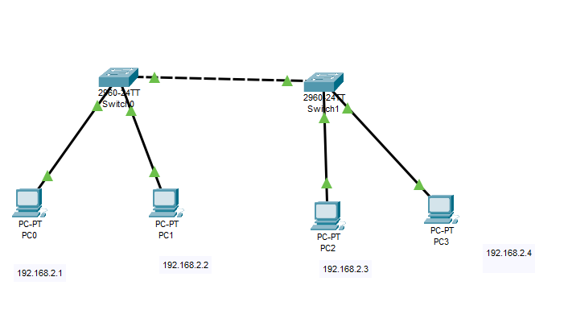

different IOS modes are:

1. User Exec mode: it allow you to connect with the remote device. It is denoted by > .

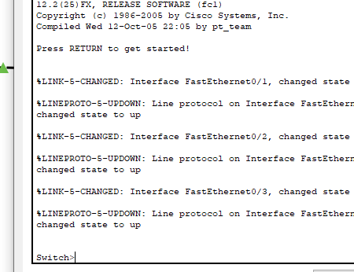

1. Privileged mode: it is denoted by #. We can easily change user mode into privileged mode by using  **enable** code in cli.

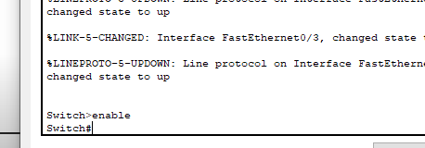

1. Global configuration mode: contains command those modify the operation of an interface. We can go into global mode from privileged to using **configure terminal.**

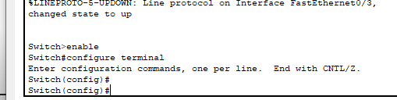

1. Interface terminal: contain command those modify the virtual interface created from physical interface.

